Layering and Safeguarding
Safeguarding user data, business information, and system integrity requires a layered defense approach. Security measures are applied at every level of the application rather than relying on a single protective boundary.
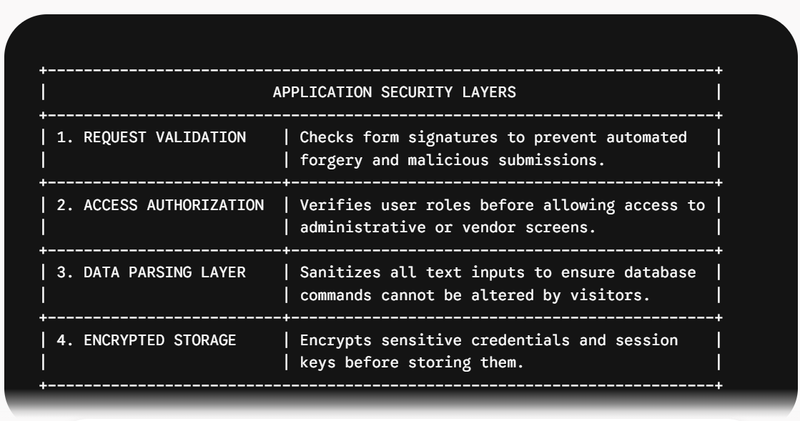
Access Control Strategies
- Role-Based Guards: Access to administrative screens and vendor store controls is restricted based on logged-in user accounts. Buyers cannot access vendor management screens, and vendors cannot edit stores belonging to other merchants.
- Store-Level Isolation: Whenever a merchant attempts to edit or delete a product listing, the system verifies that the listing belongs specifically to their store account before processing the request.
- Secure Credential Recovery: When users forget their passwords, the system sends a temporary, single-use reset link to their verified email address. These links expire after a set time window to prevent unauthorized account access.

Failure Recovery Plan
Software systems must be built to handle unexpected hardware faults, database drops, network delays, and bad inputs without corrupting data or leaving users stuck.
System Failure Architecture
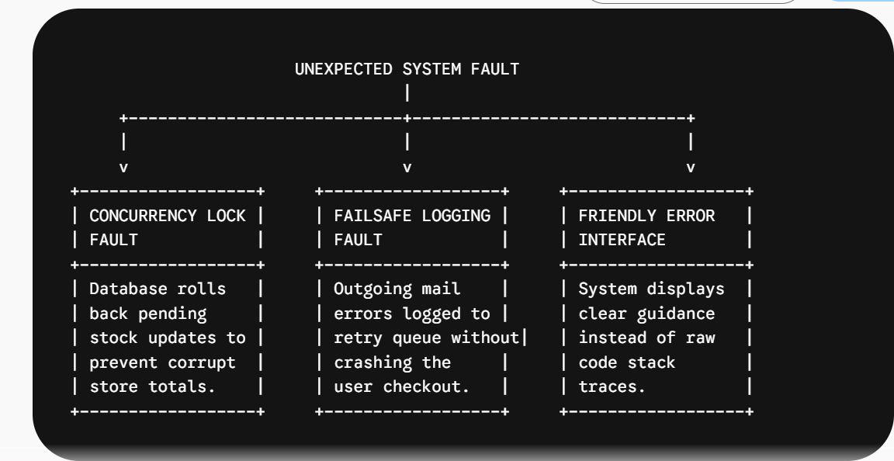
Fault Scenarios and Recovery Strategies
- Simultaneous Checkout Attempts: If two buyers attempt to purchase the final unit of a product at the exact same moment, database locking prevents both orders from processing simultaneously. The system completes the first request and gracefully notifies the second buyer that the item is out of stock.
- Email Gateway Disruption: If the email service fails while sending an order receipt, the application logs the failure to an internal queue and completes the order page for the buyer. The email dispatch is safely re-attempted in the background once connectivity is restored.
- Application Errors: When an unexpected error occurs, the system logs technical details privately for system administrators while displaying a clean, helpful error page to the user, ensuring system internals are never exposed.

